THE INTERNATIONAL SINGING CONTEST
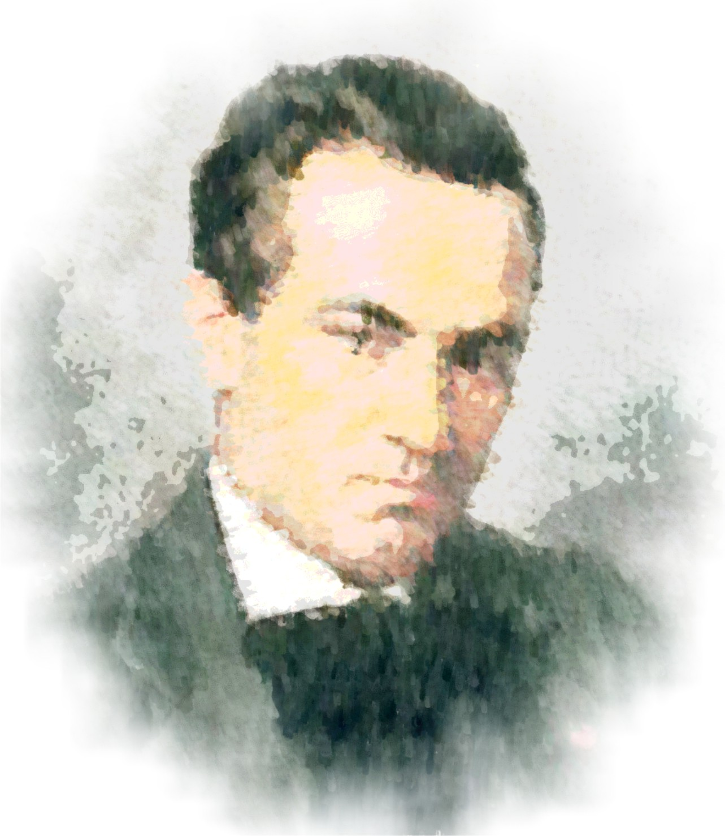
„Sabin V. Drăgoi”

8th Edition
27-30 June 2013

TIMIŞOARA, ROMANIA

The Contest is open to all young singers, irrespective of nationality, being focused on promoting talent and asuring a wider knowledge of the Romanian contemporary creations, especially the one of Sabin V. Dragoi, as well as the international one.
Organizers: Asociaţia Pro Philharmonia, Universitatea de Vest – Facultatea de Muzică Timişoara, Consiliul Judeţean Timiş, Consiliul Local Timişoara.

The Jury will be composed of well known artists, Romanian and foreign. We mention:

1. Conf. Univ. Dr. Ana Stan Slusar
Facultatea de Muzică, Timişoara, Romania
2. Radu Popa
Conductor, Filarmonica „Banatul” Timişoara, Romania
3. Conf. Univ. Dr. Bianca Manoleanu
Dean, Universitatea Naţională de Muzică, Bucureşti, Romania
4. Prof. Univ. Dr. Elena Moldovan
Dean, Academia de Muzică „Ghe. Dima”, Cluj-Napoca, Romania
5. Aura Twarowska
Solist, Opera de stat Viena, Austria
6. Mag. art. Soyung Yu
CMS International Wien
7. Rajmond Janssen
Conductor, Holland

RULES OF ENTRY AND PARTICIPATION

1. The competition is open to singers, irrespective of nationality, that are not older than 30 years, for women, and 35 years for men, at the date of entry, 10th of June 2013. There will be no exceptions regarding the age limit.
2. All eligible participants will send
-a filled-in application form,
-copy of an ID card (passaport or any id with picture and birth date),
-copy of the deposit receipt for the entry fee,
-recent portrait photograph (min. 1200 x 1200 pixels) şi
- Curriculum Vitae,
at the e-mail prophilharmonia@ymail.com, by 10th of June 2013, inclussive.
The participants will specify in the entry form ig they require lodging. Lodging and meals will be supported by the Organizing Institutions. Transport fees are not included and are to be paid by the participants.
3. Entry deadline 10th of June 2013. Any documents received after this date will not be taken into consideration.
4. Entry fee is 50 euros. The payment will be made by deposit of the sum (or RON equivalent, at the BNR exchange rate for the day the deposit is made) in the respective account:

ASOCIATIA PRO PHILHARMONIA
PIRAEUS BANK TIMISOARA
P-TA VICTORIEI NR 7, TIMISOARA, ROMÂNIA
RON ACCOUNT RO33PIRB3700720910003000
EURO ACCOUNT RO96PIRB3700720910004000
SWIFT CODE PIRBOBU

The copy of the deposit receipt must be attached to the application form and documents as explained at point 2.
5. The competition will take place during a 4 days period, from 27th to the 30th of June 2013, at the „Capitol” Concert Hall, Filarmonica „Banatul”, Romania, Timişoara, No. 2, C. D. Loga Street, and will be divided into 3 parts as scheduled
27th of June – Random selection of entry numbers and 1st part, 11 am, Capitol Concert Hall
28th of June - 2nd part, 17 pm, Capitol Concert Hall
29th of June - Etapa a III-a, 18 pm, Capitol Concert Hall
30th of June – Winner Gala, 19 pm, Capitol Concert Hall
Any modifications will be comunicated on the site, e-mail and Facebook accounts.
6. The mandatory and of choice repertory will be as follows:

1st Part:
1. Crizanteme Lied OR Flori Albe Lied by Sabin V. Drăgoi
2. An opera or concert aria arie de operă by W. A. Mozart.

2nd Part:
1. Aria of choice by:
-J. S. Bach,
-G. F. Händel,
-H. Purcell,
-A. Vivaldi,
-G. B. Pergolesi,
-Chr. W. Gluck,
-J. Haydn
2. Opera aria from universal repertory.

3rd Part:
1.A. Romanian participants will prepare an aria Sabin V. Drăgoi’s works:
-Năpasta,
-Horia,
-Constantin Brâncoveanu,
-Kir Ianulea,
-Păcală.
In case no representative aria for a specific voice exists, an aria from Romanian contemporary works can be sung.
1.B. Foreign participants will present an opera aria from an contemporary artist from country of origin.
2. Aria of choice from universal repertory.

Note: For the foreign participants the Sabin Dragoi lieds will be sung in Italian. They can be transcribed in the appropriate tonality. All other works will be sung in the language they were written in. All arias will be sung from memory.
7. The accompaniament will be provided Lect. Univ. Dr. Silviana Cîrdu (Facultatea de Muzică, Timisoara) and Angela Balici (Maestru Corepetitor la Opera Română Timişoara)in case the participants do not bring their own.
8. The jury will give 4 prizes (Grand prize, 1st, 2nd, 3rd), one onorable mention, special prizes „Marius Iuliu Mare” and „Mirela Zafirii” , wich will composed of money, but also prizes that will be composed of contracts for a number of concerts.
9. The Winner Gala is mandatory for all prize winners. Unattendance will result in the jury’s reclaiming the prize.
10. The jury’s decisions are final and can not be contested.
11. All competition will be held with public, who can attend free of charge.
12. All participants will be present at the Capitol Concert Hall an hour before any competition part, and will respect the entry order established by the random selection made on the first day, or the last one made.
13. If the participants do not bring their own music sheets and accompaniament then they will be have to accept the ones provided by organizers.
14. Asociaţia Pro Philharmonia reserves the right to record and distribute, reproduce and transmit audio and videos of the contest, so participants can not claim rigths over their performance in this competition.
15. By signing the entry form for the competition we consider that the participants understand and accept these rules completely.

Contact info

All information will be available in english at the web address:
www.sabindragoi.muzica.uvt.ro
For further information you can contact:

ASOCIATIA PRO PHILHARMONIA
Romania, Timisoara, str. C. D. Loga nr 2

Oana Borlea
Executive Director
+40720 612 763

prophilharmonia@ymail.com
www.facebook.com/Prophilharmonia
www.twitter.com/#!/ProPhilharmonia
www.filarmonicabanatul.ro/pro-philharmonia

UNIVERSITATEA DE VEST, FACULTATEA DE MUZICĂ

Asist. Univ. Drd.Ioana Mia Iuga
Musical Secretary
+4 0723 715 255

The music sheets for mandatory pieces will be availlable in the competition website. Application forms will be availlable at the same website.

APPLICATION FORM

- LAST NAME
- FIRST NAME
- PLACE OF BIRTH
- BIRTHDATE
- NATIONALITY
- LAST GRADUATED SCHOOL

- MENTOR

- TYPE OF VOICE

- HOME ADDRESS

- CORRESPONDING ADDRESS (IF DIFFERENT FROM HOME ADDRESS)

- TELEPHONE NO.

- E-MAIL
- REPERTORY
1st PART
2nd PART
3rd PART

- I require lodging: YES/NO
- I will bring my own accompaniament YES/NO
If yes please mention the persons name
- With this form I have also sent:
- 1 copy of ID card
- 1 copy of entry fee deposit
- 1 recent portrait photo (min. 1200 x 1200 pixels)
- Curriculum Vitae
- By signing this form I hereby declare, fully aware of the law regarding false declarations, that the data provided is complete and real.
- By signing this form I hereby declare that I understand and accepted fully all the rules of entry and participation.

Place and date of signing ,

Last Name, Name (visible),
Signature

